T 2.1 – MySQL databanken gebruiken vanuit PHP

# MySQLi

## Code

**<h1>MySQLi Example</h1>  
  
<?php  
$servername** = **"localhost"**;  
**$username** = **"root"**;  
**$password** = **"steven123"**;  
**$dbname** = **"steden"**;  
  
**// Create connection  
$conn** = **new** mysqli**($servername, $username, $password, $dbname)**;  
  
**// Check connection  
if ($conn**->**connect_error) {  
 die("Connection failed: "** . **$conn**->**connect_error)**;  
**}  
  
//define and execute query  
$sql** = **"select** *\** **from images"**;  
**$result** = **$conn**->query**($sql)**;  
  
**//show result (if there is any)  
if ($result**->**num_rows** > 0**)  
{  
 // output data of each row  
 while($row** = **$result**->fetch_assoc**())  
 {  
 echo $row["img_id"]** . **"<br>"**;  
 **echo $row["img_filename"]** . **"<br>"**;  
 **echo $row["img_title"]** . **"<br>"**;  
 **echo "w:"** . **$row["img_width"]** . **"<br>"**;  
 **echo "h:"** . **$row["img_height"]** . **"<br>"**;  
 **echo "<br>"**;  
 **}  
}  
else  
{  
 echo "No records found"**;  
**}  
  
$conn**->close**()**;  
**?>**

## Output

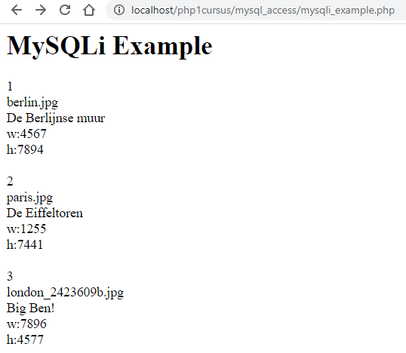

# PDO

## Code

**<h1>PDO Example</h1>  
  
<?php  
$servername** = **"localhost"**;  
**$username** = **"root"**;  
**$password** = **"steven123"**;  
**$dbname** = **"steden"**;  
  
**// Create and check connection  
try {  
 $conn** = **new** PDO**("mysql:host=$servername;dbname=$dbname", $username, $password)**;  
 **$conn**->setAttribute**(**PDO::***ATTR_ERRMODE*,** PDO::***ERRMODE_EXCEPTION*)**;  
**}  
catch(**PDOException **$e) {  
 echo "Connection failed: "** . **$e**->getMessage**()**;  
**}  
  
//define and execute query  
$result** = **$conn**->query**("select** *\** **from images")**;  
  
**//show result (if there is any)  
if ( $result**->rowCount**()** > 0 **)  
{  
 $rows** = **$result**->fetchAll**(**PDO::***FETCH_ASSOC*)**;  
  
 **// output data of each row  
 foreach ($rows as $row)  
 {  
 echo $row["img_id"]** . **"<br>"**;  
 **echo $row["img_filename"]** . **"<br>"**;  
 **echo $row["img_title"]** . **"<br>"**;  
 **echo "w:"** . **$row["img_width"]** . **"<br>"**;  
 **echo "h:"** . **$row["img_height"]** . **"<br>"**;  
 **echo "<br>"**;  
 **}  
}  
else  
{  
 echo "No records found"**;  
**}**

## Output

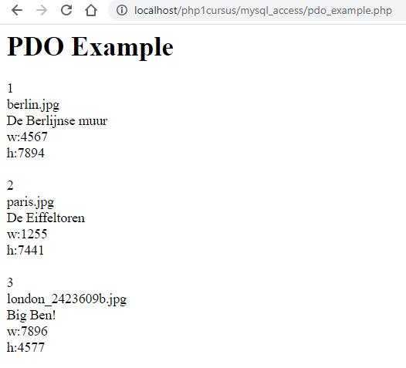

## Vergelijking PDO – MySQLi

<https://websitebeaver.com/php-pdo-vs-mysqli>